Instructions for Preparing a Manuscript for NGL; Title of Summary should be Provided Here [16 pt], 2 Pages

Gildong Hong¹, Gildong Kim², and Gildong Lee^{1,*}
¹Department of Physics, Seoul National University, Seoul, 08826, Korea
²Korea Research Institute of Standards and Science, Dajeon 34113, Korea
* gildonglee@snu.ac.kr (e-mail address for corresponding author)

Abstract – A short summary of your work should be here (less than 200 words). A short summary of your work should be here (less than 200 words). A short summary of your work should be here (less than 200 words). A short summary of your work should be here (less than 200 words). A short summary of your work should be here (less than 200 words). A short summary of your work should be here (less than 200 words).

I. Introduction
This document can be used as an English template to prepare a summary for NGL Student Paper Awards. Please note that the length of the manuscript should be 2 page (1 column, single spacing format).

II. Result and Discussion
Please use “Times New Roman” font in preparing the summary.
The first line of each paragraph should be indented by 0.42 cm. Please check the font size of each section as follows. Title (16 pt), author name (10 pt), affiliation (9 pt), abstract (9pt), main text(10 pt), figure caption and reference (9 pt). You can include the figure as below with figure caption.
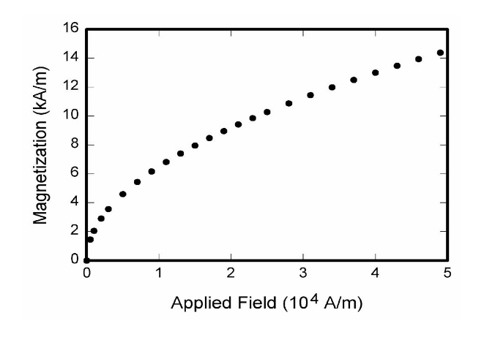
Fig. 1 This is figure caption for Fig. 1

The reference can be numbered as superscript⁽¹⁾ in the main text and its information should be provided with proper format at reference section.

III. Conclusions
Please use “Times New Roman” font in preparing the summary.
The first line of each paragraph should be indented by 0.42 cm

Acknowledgements (If applicable)

References
[1] Authors name, “Instruction about reference format for OSK meeting”, JOSK 5, 1-20 (2015).

